**Deliverable 1: Word Document answering the following questions with graphs or tables:**

1. **[SQL]** Do evening games (6:00pm or later) on average, have a higher scanned attendance than afternoon games (Before 6:00pm)? Also, provide average attendance per game by month.

**Evening games has higher attendance on average:**



**Average attendance per game by month:**

1. **[SQL]** Count the number of UCP members with reservations >=5 and scans >=3. Of these, how many UCP members attended every game they reserved?
   1. **330**

* B. there are 26 people who scaned every time they reserved

NOTE: TENANT MEMBER NUMBER: 1000-000-0000 represent ticket add-ons and can be dropped from this question

1. **[SQL]** Find the average cost of a single game ticket for each game in the dataset provided. Then compare the total value if all UCP eligible games were purchased at their average single game price, against the UCP package price. Assume the UCP package price is $350.

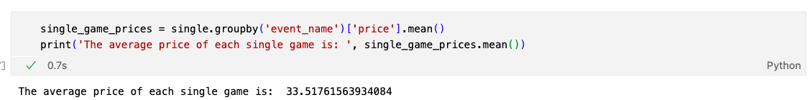

350/10 = $35 per game for UCP members.

NOTE: G41 vs POR can be excluded from the single game total calculation.

1. Pull data from Basketball Reference around [22/23 game schedule](https://www.basketball-reference.com/teams/LAC/2023_games.html). Is there a difference in reservations and scans for UCP members and single game buyers during homestands where LAC plays 3 or more consecutive home games (ie: no road games in between), vs all other games? Optional: Include code for scraping Basketball Reference and pulling in data.
   1. Code for web scrapping:

* 1. Data analysis of homestands v.s. not homestands: Chart, box and whisker chart

     Description automatically generated
  2. Chart, bar chart

     Description automatically generatedChart, box and whisker chart

     Description automatically generated Chart, bar chart, histogram

     Description automatically generated
  3. Chart, box and whisker chart

     Description automatically generatedChart, bar chart

     Description automatically generatedChart, box and whisker chart

     Description automatically generatedChart, bar chart

     Description automatically generated